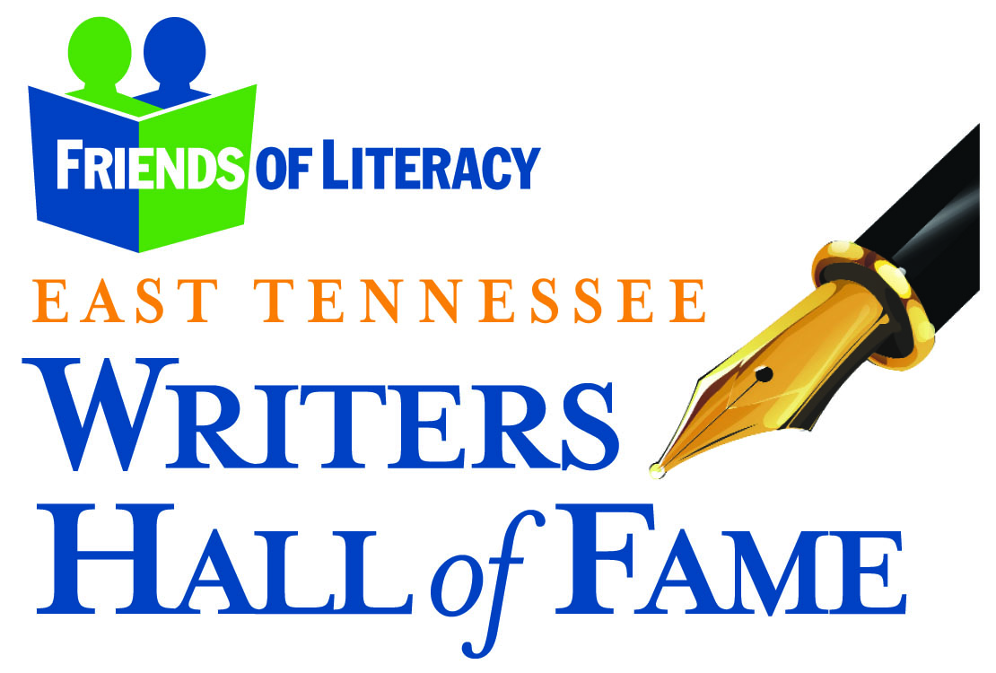
2017 East Tennessee Writers Hall of Fame
Media Sponsorship Opportunities

The 14th annual East Tennessee Writers Hall of Fame to benefit Friends of Literacy will be held on October 19, 2017, at 11:30 am at the Lighthouse Knoxville for over 250 guests. During the event, Friends of Literacy will induct five local writers into the East Tennessee Writers Hall of Fame in the categories of fiction, poetry, social media, non-fiction, and Lifetime Achievement.

In exchange for $5,000 in in-kind advertising you will receive the following benefits:

- Sponsor logo/name will appear on award named after sponsor and opportunity for a sponsor representative to present award
- Sponsor logo/name will appear on all applicable advertisements
- Listed in the program and event invitation
- Sponsor acknowledged at event
- Logo/name on signage at event
- Name mention in all event related press releases
- One table at the awards lunch (seating for 10)

The Problem
In 2003, 23 million adults or 14% of the population in the United States were described as “functionally illiterate,” meaning they do not have the skills needed to effectively participate in an increasingly complex society. Statewide, Tennessee has the 6th highest illiteracy and school dropout rate in the country. Locally, over 10,000 adults in Knox County are unable to read or write above a 6th-grade level. This means job applications cannot be completed, instructions on prescription medication cannot be read, and children cannot be helped with homework. Over 40,000 adults in Knoxville lack a high school diploma or GED that is 1 in 8 adults in our community. This is a tragedy for the individual and the entire community.

The Challenge
As discouraging as the news is there is hope. Friends of Literacy, a non-profit organization, works to support the delivery of high quality literacy, basic education and life-skills programs and related services to adults in Knox County who are inadequately educated to meet the challenges of daily life. Our region will benefit as individuals are empowered through education to become better parents, workers, and citizens.

The Cure
The work that is being done to break the grip of illiteracy in our county would not be possible if not for concerned citizens like you. Approximately 1/4 of our annual budget is raised at the annual East Tennessee Writers Hall of Fame. This year we will present the 14th annual East Tennessee Writers Hall of Fame awards on October 19, 2017.

The East Tennessee Writers Hall of Fame
Friends of Literacy realizes how important authors’ contributions are to our culture and history and we wish to honor those who entertain, inspire, and inform us through the written word. Nominations are sought for five categories: lifetime achievement, fiction, non-fiction, poetry and social media. An independent panel of judges evaluates the nominees based on recognition within the writer’s field, longevity, quality, and volume of work. All nominees must have either been born in, currently reside in, or have a body of work related to the East Tennessee region. At the event, selected writers are inducted into the Hall of Fame. In addition, an award is presented to a deserving adult student selected from essay entries.

The work that is being done to break the grip of illiteracy in our county would not be possible if not for concerned citizens like you who chose to participate in the Hall of Fame event. Please consider becoming a sponsor so that you can be a part of eradicating literacy in Knox County and honoring area writers.

